Mr. Kevin & Melissa
34 London Road Park
Greenford
Middlesex
UHY 238

31st July 2023

Dear Kevin and Melissa,

Your Annual Review Report

Please find enclosed a copy of your Annual Review Report.

I would be grateful if you would both sign the Acceptance Declaration and Risk Report using DocuSign, which is via a platform that allows you to complete and sign documents using a digital signature.

Whilst signing in this manner, you are confirming you have read and understood the contents of your report.

We would normally endeavour to send this letter to you within a month of the review taking place.

I apologise for this delay and if you would like to discuss It further, please do not hesitate to contact me.

Yours sincerely

Chris Gillespie
Financial Advisor (DipPFS)

Annual Review Report
Prepared for
Mr Kevin and Mrs Melissa
31st July 2023

AAI Financial Planning



Introduction
Further to our recent meeting, this report confirms a summary of your annual review and any proposed action we agreed upon.

I am still authorised as an Independent Financial Adviser to provide independent, unbiased and unrestricted advice and have already provided you with a copy of my Service Charter which includes details of our services, charges, and details of our Wealth Management Service Proposition.

This report is based on the information provided by you regarding your financial circumstances, on our understanding of current legislation and on the assumption that you are resident in the United Kingdom. Any material facts that have not been provided, or have been incorrectly stated or omitted by you, could affect the scope and suitability of my recommendations.

Please read this report carefully to ensure that my assumptions are correct and that you have understood the issues and any risks involved. If there are any points on which you are unsure or require further clarification, please contact me and I will be pleased to explain these in greater detail.

Plans Reviewed
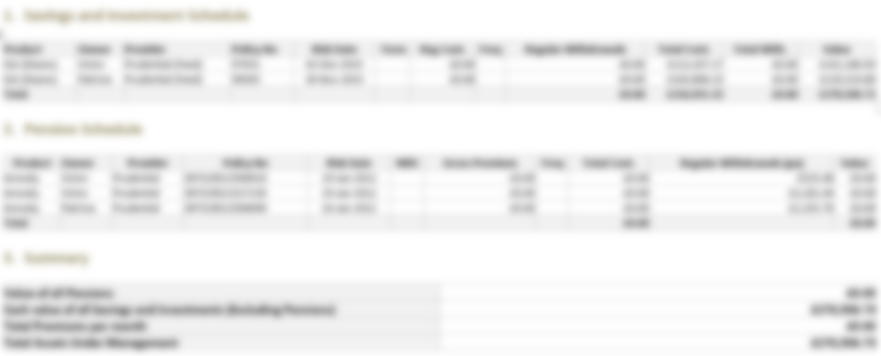

Current Circumstances
Your current circumstances remain broadly the same as outlined in my last report dated 31st July 2023.

You confirmed that your current level of income and expenditure, is as follows:

Income | Kevin | Melissa
Salary
State Pension | £12,075 | £8,222
Annuity Income | £7,063 | £2,852
Final Salary Income |  | £1,495
Drawdown Income
Rental Income
Other Income
TOTAL | £31,707

Expenditure | Joint
Fixed Costs | £13,800
Other | £6,900
TOTAL | £20,700

To manage your portfolio and the amount of tax payable on withdrawals to improve the sustainability of your pension and investments it is important you tell us if anything changes. This also helps us preserve the amount that can be passed on death to your family.

You have confirmed that you've given small presents to your grandchildren this year, but nothing of substantial value.

Furthermore, there have been no capital gains for you this year.

Emergency Funds
An emergency fund is easily accessible cash within a relatively short period of time and is important, so you do not have to encash assets or investments to fund unplanned expenditure at an inappropriate time. An amount equal to 3-6 times your monthly income should be held on deposit in instant access Cash ISAs (Individual Savings Accounts) or National Savings Premium Bonds, as returns are tax-free.

Based on the information provided, it seems that you have a sufficient emergency fund in place.

Inheritance Tax
As I explained Inheritance tax is charged on your death at the rate of 40% based on the value of your assets. This 40% rate is only charged on any value exceeding the nil rate band. The nil rate band in the tax year 2022/2023 is £325,000 each.

In addition, a residence nil rate band applies so that less inheritance tax may be paid when the family home is left to children, grandchildren and some other individuals, the residence nil rate band is £175,000 each. So, your combined inheritance tax nil rate band is £1 million before your estate would be liable to inheritance tax.

Based on the valuation provided, your total estate is approximately £1,445,500. This means that your estate exceeds the £1 million threshold, and according to the calculation on the next page, there is an Inheritance Tax liability of approximately £178,200.
Inheritance Tax Calculation
Assets
Main house |  |  |  |  |  |  | £940,000.00
Cash - eg. Bank/building society accounts |  |  |  |  |  |  | £105,000.00
Investments - eg. Shares, funds, Investment Bonds and ISAs |  |  |  |  |  |  | £400,500.00
Other assets - eg. Cars, holiday home, boat, personal effects, jewellery
Life insurance (not under a suitable trust) eg. Term assurance payout
Pension death benefits that are included within the estate
Existing IHT efficient investments/assets (eg business property relief)
Other assets
Previous gifts that are still liable to IHT
 |  |  |  |  |  | Total | £1,445,500.00
Less any Liabilities
Mortgage(s)
Loans, overdraft
Credit cards
Other expenditure - eg. Bills, hire purchase, funeral expenses etc
 |  |  |  |  |  | Total | £0.00
 |  |  |  |  |  | Subtotal | £1,445,500.00
Calculating the IHT liability
Nil rate band (2022/2023) - £325,000 per individual |  |  |  |  |  |  | £650,000.00
Percentage of additional unused nil rate band, where applicable (%) |  |  |  |  |  |  | 0.00%
Total nil rate band available |  |  |  |  |  |  | £650,000.00
Will the residence be left to direct descendents? |  |  |  |  |  |  | Yes
Residence nil-rate band (2022/2023) - £175,000 per individual |  |  |  |  |  |  | £350,000.00
Percentage of additional unused residence nil-rate band |  |  |  |  |  |  | 0.00%
Amount lost due to tapering as estate worth >£2m |  |  |  |  |  |  | £0.00
Total Residence nil-rate band available |  |  |  |  |  |  | £350,000.00
Subtract any future exemptions (eg small gifts or charity donations) |  |  |  |  |  |  | £0.00
Subtract existing assets exempt from IHT |  |  |  |  |  |  | £0.00
Balance on which IHT payable |  |  |  |  |  |  | £325,000.00
IHT liability @ 40% (potential liability) |  |  |  |  |  |  | £178,200.00
The figures provided by the calculators are not guaranteed and are based on the information provided by you as well as our understanding of current legislation and tax rates. Actual figures may vary and the calculations should only be used as a general guide.
Summary of Our Discussion Points along with your thoughts
I have recommended in the first instance that you carefully consider your own needs and indeed place a priority to your financial security before you start to consider methods to potentially reduce your Inheritance Tax liability.

Spending, Gifting, and Investing
We then discussed the three most common methods of Inheritance Tax mitigation.

1: Spending
You are well-informed about the current Inheritance Tax (IHT) situation, and you have a plan to revamp your backyard using the equity in your property through a lifetime mortgage. This strategy aims to decrease your IHT liability. As we discussed, we will delve into this matter further once you have gathered cost estimates for the planned home improvements.

2: Gifting
Lifetime gifts do not count towards the estate for the purposes of working out if the estate is valued at more than £2 million. This is especially important when preserving the Residence Nil Rate Band.

All gifts between individuals (also known as potentially exempt transfers or PETs) and to certain trusts, as long as you don’t reserve any right to benefit from the gifts, will be outside your estate and therefore not liable to Inheritance Tax, providing you survive for seven years from the date the gift was made.

A commonly overlooked opportunity is for regular gifts out of income. For those people who have a comfortable income and make a habit of making gifts on a regular basis, these gifts have the potential to be exempt from Inheritance Tax immediately. There is no limit on the amount you can gift as long as it is made out of income (as opposed from capital), regular (or at least must be intended to be regular) and doesn’t reduce your standard of living so that you have to use capital to maintain income. If you use this exemption, it is essential that you document it fully.

Making regular gifts out of excess income can be a useful way to prevent further increases in your estate's taxable value. For example, you could make gifts to your family for the following purposes:

- Pension contributions for adults or minors
- Building up ISA or Junior ISA subscriptions, or
- Sending the family on regular holidays every year.

Make use of lifetime exemptions. Donors don’t need to survive seven years for some gifts to become exempt from. There are several lifetime exemptions that you can make use of as well:

Lifetime Exemption | Exempt Amount
Annual exemption | £3,000
Unlimited Small gifts | £250 per recipient
On marriage/civil partnership:
Each parent can donate | £5,000
Each grandparent can give | £2,500
Remoter relatives/well-wishers | £1,000

There are other exemptions for gifts to charities, political parties, universities and for national purpose or public benefit. For example, gifting 10% of an estate to charity reduces Inheritance Tax on the net balance to 36%.

During our discussion, we explored the option of gifting as a means to reduce your estate's Inheritance Tax burden. It was noted that you are already engaged in giving small gifts to your grandchildren. You are well aware of the opportunity to make gifts of up to £3,000 each, which will be immediately excluded from your estate for tax purposes. It is advisable to maintain proper records of these gifts for audit purposes, ensuring a smooth process if required in the future.

3: Investing
During the conversation, I provided information about more specialized investment options, such as Business Property Relief (BPR) and Enterprise Investment Schemes (EIS). These avenues offer higher potential risk and reward.

However, you expressed that you are not currently interested in exploring these options. We agreed to revisit this topic during our next annual review to reassess your preferences and financial goals at that time.

Planning within your Will
I explained that your Will should be seen as the foundation of your Inheritance Tax planning and we also discussed the importance of considering a Lasting Power of Attorney (LPA).

You might become unable to manage your own affairs later in life and therefore any Inheritance Tax mitigation decisions might not be possible to be continued. If you arrange and register a Lasting Power of Attorney (LPA) to carry out your wishes during your lifetime, this can be of significant benefit. This must be in place of course before you lose the ability to make your own decisions.

There are two types of LPA, one covering financial matters, and the other health and welfare decisions. Completing an LPA does not mean someone can immediately control your life and finances, and indeed there are strict laws to say that they must act with your best interests in mind. An LPA can only come into play at the point of need, if you specify this.

The benefit to you is that you can appoint someone whom you have complete trust and understands your objectives and financial goals. If you do not appoint an attorney, your relatives will have to apply to the Court of Protection if you lose the ability to make your own decisions. This can be a slow and expensive process and you will not be able to select your own attorney or perhaps be clear and specific about how you would like your affairs to be managed.

During our discussion, it came to my attention that you have not yet arranged Lasting Power of Attorneys (LPA). I would like to emphasize the importance of setting up LPAs with the assistance of your solicitor as soon as possible. This will provide you and your loved ones with peace of mind, ensuring that your affairs are managed according to your wishes in case of any unforeseen circumstances.

On a positive note, your will is currently up to date, and you have no immediate plans to make any changes to it. However, I recommend reviewing your will periodically to ensure it aligns with your current circumstances and preferences. If any changes become necessary in the future, we can address them accordingly.
Consumer Duty
The FCA have recently launched new piece of legislation called Consumer Duty. Within it, FCA has asked for us to demonstrate how we, as your advisers, have added value over to you over the past 12 months.

We believe there are key four areas we add value to you each year:

- Asset Allocation & Portfolio Rebalancing
- Withdrawal and Tax Strategy
- Cost Management
- Cashflow Planning

We will elaborate on these areas throughout this letter.

Asset Allocation & Portfolio Rebalancing
One of the benefits of engaging with 3D Financial Planning is that we continually ensure your money is looked after by ensuring your investments are actively managed in line with your risk profile. This is covered by two main areas:

Asset Allocation
As your adviser we ensure you are getting the right ‘mix’ of investments which is the most important investment decision. By defining your objectives for the investment, we ensure you have a well-diversified portfolio, identifying the right mix of investments for you based around your agreed level of risk. To ensure we make the right decisions with strategic asset allocations we ensure our investment committee use their extensive asset class research of the whole of the market so we can build portfolios that maximise returns for each level of risk.

Portfolio Rebalancing
To maintain the right mix of investments, you need to rebalance the portfolio every so often. This involves selling some of the investments and using the money to top up the others. Emotionally, this can be difficult to do, as we can become attached to certain investments. We review your portfolio objectively and rebalance as required. This ensures that you maintain the right mix of investments in line with your attitude to risk.
Performance
As part of your annual review, we conduct an analysis of how your investment portfolio performed relative to the peer group. This assessment entails benchmarking your investment strategy against a suitable benchmark index that aligns with your risk profile.

In this regard, we use benchmark indices provided by The Investment Association (IA).

The Investment Association (IA)
Formerly called the Investment Management Association (IMA), the IA measure performance over 50 different sectors. Sector definitions are mostly based on assets, such as equities and fixed income and other asset classes. Funds in the mixed sector are required to have a range of different investments. Each has a maximum percentage that the fund can be invested in company shares (equities). And a minimum percentage of the fund must be in fixed income investments (for example, corporate and government bonds) and/or “cash” investments. “Cash” can include investments such as current account cash, short-term fixed income investments and certificates of deposit.

The index most aligned with your level of risk is the IA Mixed Investment 20-60% Shares index. The graph below shows the comparison between the benchmark and your portfolio over the 12 months and over the last 3 years, on a like-for-like basis*:

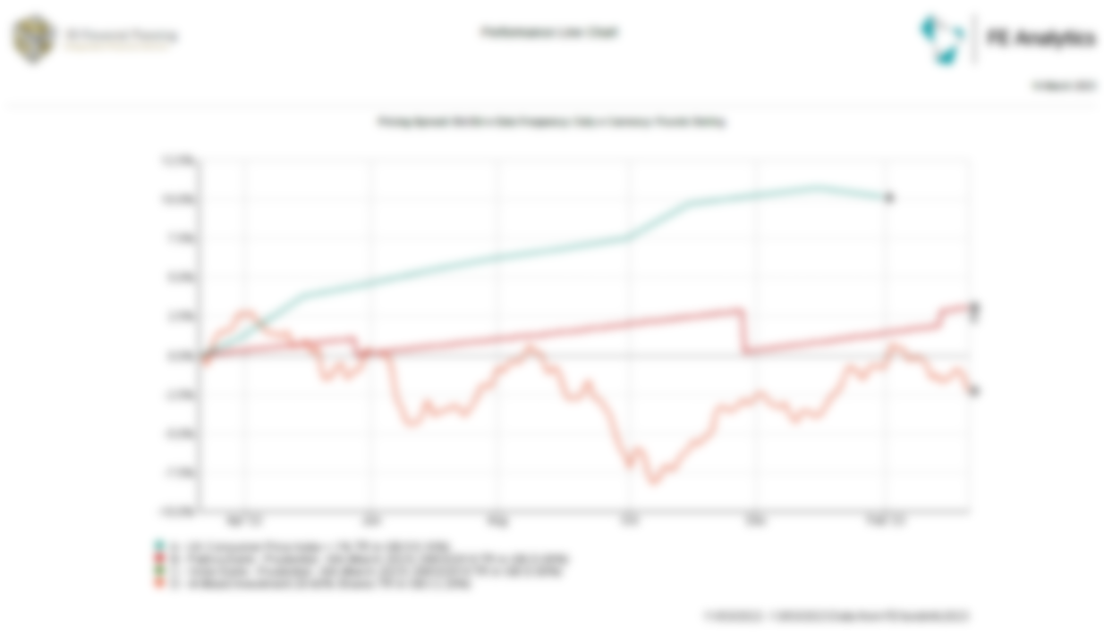
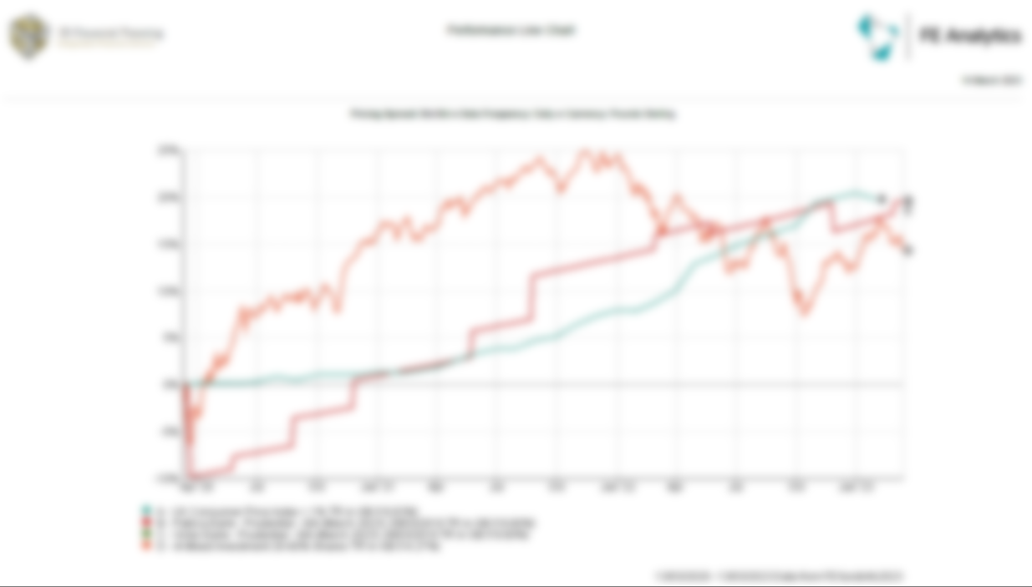

*The figures above show gross performance figures and do not account for product or adviser charges, if applicable. Please refer to your Portfolio Valuation Report for net performance.

As you can see, your portfolio has returned 1.13% over the last 12 months, compared to the IA Mixed Investment benchmark 20-60% Shares, which has returned -2.29% over the same period.

This indicates, in relative terms, an outperformance of 3.42%, in the last year.

We also measure your performance against inflation which for your level of investment risk is measured at CP1+1% which has grown by 10.16%.

Please note that the returns achieved for your portfolio is net of all charges, whereas the benchmark does not take into account any charges for products or advice.

You confirmed that you were happy with the performance.

Investing can provoke very strong emotions. When our investments fall by 20%, we panic. When our investments rise by 20%, we celebrate. The problem is, we’re all human. We’re hard-wired to avoid pain and seek pleasure. So, we sell our investments when they fall, and we buy them when they rise.

We will continue to provide sound, objective advice, helping you stick to your long term goals and objectives and remain invested by providing you our monthly investment newsletters.

Market Commentary
The last 12 months has seen increased volatility within the financial markets which has effected portfolio returns and the rate of inflation which in turn has led to the current cost of living crisis.

Most notably, the war in Ukraine meant has disrupted global supply chains and impacted exports from the region for commodities like metals, food, oil and gas, pushing up inflation to levels not seen in decades. This has weighed heavily on financial markets and has impacted portfolio returns.

Furthermore, China’s persistence with their (now abandoned) “Zero Covid” policy for much of 2022 put additional strain on supply chains and further contributed to the rise in inflation.

As a result, central banks and policymakers responded by increasing interest rates which effected the performance of so-called “growth” equities and led to a resurgence in more traditional “value” stock, such as banks and utility providers.

In terms of the fixed income market, this too has been impacted by the rising interest rates and domestically, the government bond market was affected by Liz Truss’s mini-budget in September 2022.

Looking ahead, with the Chinese economy no longer restricted by covid-related lockdowns, supply chains will function more efficiently which will help to reduce the upward pressure on inflation. Additionally, with the wholesale price of gas reducing to pre-war levels, the expectation is that inflation figures will start to cool over the next 12-18 months, which could lead to central banks slowing or even reversing their rate hike cycle. All of which will be positive news for the financial markets and we’re hopeful this will result in better returns in the following 12 months.

Attitude to Investment Risk and Capacity for Loss
During our meeting, I offered you the chance to complete a new risk questionnaire. However, we both recognized that your circumstances have remained relatively stable since we last completed the questionnaire in May 2022. As a result, we agreed that there is no immediate need to update the risk assessment at this review. However, I encourage you to let me know if there are any significant changes in the future that may warrant revisiting the risk assessment to ensure your financial strategy remains aligned with your goals and risk tolerance. Your risk profile is outlined below. The latest Risk Profile is provided within the appendices of this report. Please sign and return this document to me to confirm your understanding of the agreed risk profile.

Risk level from questionnaire | Agreed risk level | Time Horizon
5/10 | 5/10 | 10+ years
Risk Level 5 - People in this category have a medium risk tolerance, and would probably prefer investments to fluctuate less and make more modest returns than risk losing money for higher returns. It is likely that you are looking for a balance of risk and reward, with the potential for higher returns in the longer term, and you may have some experience of investment, including investing in products containing riskier assets such as equities and bonds or may be willing to take some risks with your capital. You are probably prepared to accept some fluctuation in order to make higher returns than exclusively low risk investments and are aware that the value of your investment will rise and fall. Examples of investments may include Fixed Interest Securities, Property, UK Equities, and International Equities. You could get back less than you invested.

As part of our ongoing service, we need to determine that you are able to accept this level of investment risk by determining if you as an individual have the appropriate capacity for loss (your ability to accept loss to capital and / or income without detriment to your lifestyle / standard of living).

Based on your circumstances I feel you have the capacity for loss to accept this level of risk at this stage.

Your attitude to investment risk will be kept under review and is part of the wealth management service 3D Financial Planning can offer going forward to ensure you are not only comfortable with the level of risk you are taking but it is appropriate for your personal and financial circumstances at any given point in time.

Investment Style Preferences
Following on from your risk profile, we also reviewed the current investment style applied to your investments to ensure it meets your own individual requirements.

We live in a world today that provides you many different investment opportunities but deciding what is right for you is key to ensuring the correct investments are picked for you.

The different investment styles can be put into four categories, and each are completely different:

- Active
- Passive
- Ethical
- ESG – Environmental, Social and Governance

During our discussion, we reaffirmed that your investment portfolio continues to follow an active strategy. We both agreed that this approach aligns well with your current financial preferences and objectives. By maintaining an active strategy, we aim to capitalize on market opportunities and navigate potential challenges to help you achieve your financial goals effectively. Should your preferences change in the future, we can always reevaluate and adjust the investment strategy accordingly.
Current Circumstances
You and your partner are in good health and spirits. Recently, you both returned from a rejuvenating vacation, and now you are eager to discuss your financial plans for the future. You mentioned that you have been regularly exercising, feeling more energetic, while your partner expressed an interest in starting yoga classes for flexibility and stress reduction.
During the meeting, you reviewed your financial situation and were pleased to find that your investments performed well in the last quarter. This has given you confidence that your current income will comfortably cover your expenses.
Regarding home improvements, you had previously considered renovating your kitchen but decided it wasn't a priority. Instead, you are now looking into revamping your backyard to create a beautiful outdoor living space. Currently, you are gathering quotes from different contractors and will proceed with the project once you find the most suitable one.
Discussing your investment strategy, you both decided to focus on long-term stability. You are enthusiastic about diversifying your investment portfolio by exploring environmentally sustainable funds to support companies with strong ethical practices.
Education for your children is important to you, and you expressed a desire to start saving for their future expenses. The plan is to open separate savings accounts for each child and contribute regularly to ensure their education is financially secure.
Estate planning was another crucial topic during the meeting. You are interested in setting up a trust to protect your assets and minimize inheritance tax for your beneficiaries. To gain professional advice on this matter, you've decided to consult with an estate planning attorney.
To monitor progress and stay on track with your financial goals, you both agreed to schedule another meeting in two months. During this time, you will review home improvements, investments, and estate planning. Additionally, you will evaluate your budget and make necessary adjustments.

Actions Agreed / Recommendations Going Forward
After a thorough review of your portfolio, I believe that your ISA plans and funds continue to be well-suited for your current needs and circumstances. As a result, we reached an agreement that no changes are necessary at this moment. Our decided course of action includes proceeding with the backyard revamp to create an inviting outdoor living space, exploring environmentally sustainable investment funds to diversify your portfolio, initiating savings for your children's education expenses through separate accounts, setting up a trust to safeguard your assets and minimize inheritance tax, and scheduling a follow-up meeting in two months to monitor progress and address any further adjustments.

Reviews
By choosing to proceed with our wealth management service, you have ensured that your portfolio will be continuously monitored and managed in accordance with our client service agreement. It is crucial to regularly review your investment plan to ensure it meets your expectations and remains well-suited to any potential changes in your personal and financial situations, just like with any investment. This approach guarantees that your investments align with your goals and adapt to your evolving needs, providing you with the utmost financial confidence.
Product and Adviser Charges
As you know we charge you for the ongoing review of your plans and our professional services. We agreed that you would like to continue receiving this ongoing review for the next twelve months and will be treated as a preferential client so therefore you will be charged 0.80% on your plans as outlined in the aggregated costs and charges table below.

Provider and Product | Product/ Admin Charge | Fund  Charge | Platform Charge | Total Provider Charge | Ongoing Adviser Charge | Total Annual Charge
 | % and £ | % and £ | % and £ | % and £ | % and £ | % and £
Prudential ISA - Kevin | 0.00% | 1.25% | 0.00% | 1.25% | 0.80% | 2.05%
 | £0.00 | £1,764.84 | £0.00 | £1,764.84 | £1,129.50 | £2,894.33
Prudential ISA - Melissa | 0.00% | 1.25% | 0.00% | 1.25% | 0.80% | 2.05%
 | £0.00 | £1,616.50 | £0.00 | £1,616.50 | £1,034.56 | £2,651.06

The costs and charges which have been advised to us by the product and fund providers, at the time of completing your annual review. While we have attempted to obtain full details, there may be additional costs and charges associated with the running of your portfolio, that have not been disclosed. Please refer to your providers annual statement for further details.

Based on your requirements detailed above and our methodology for our clients who have an existing product that has previously been reviewed or recommended by us as being suitable and appropriate, it is our opinion that although there may be marginally more competitive contracts available, the cost of transferring your existing contract outweighs any potential benefits and we would prefer to avoid incurring any additional fees.

Cost Management
As your advisers we continue to monitor and look to reduce your charges by providing access to institutional investments with lower costs, this ensures you keep more of any investment return for the longer term.

Withdrawal and Tax Strategy
Tax may not only be a major drag on your investment returns, it can also effect the sustainability of your assets when drawing an income in retirement. Selecting the right ‘tax wrapper’ and withdrawal approach is just as important as selecting the right investment strategy.

It is equally important to ensure you are making use of any tax allowances and reliefs set out by HMRC where possible. This is something that we consider when recommending and reviewing both accumulation and decumulation strategies for you.

When we look at your financial planning, we look at all the aspects planning we can provide you across your different areas of advice. This is why we have previously recommended the following:

Introduction
- We took a detailed look at your current income, expenses, assets and liabilities to gain a clear understanding of your current financial situation.
- Based on your unique goals and objectives, we developed a customized financial plan that includes strategies for investing, retirement planning and tax planning to help you reach your goals.

Investment and Tax Planning
- We help you make informed decisions about where to invest your savings, based on your financial situation, financial goals and risk tolerance.
- Emphasise the importance of an emergency fund to cover unexpected expenses.
- Make use of Individual Saving Accounts (ISA) to save on taxes for long-term savings and investments.

Estate Planning
We help you plan for the distribution of your assets after you pass away by helping you navigate the estate planning landscape and put strategies in place to minimize any inheritance tax burden applied to assets passed onto your beneficiaries.
- We take a detailed look at your current assets, such as property, investments, and cash, as well as liabilities, such as mortgages and debts, to gain a clear understanding of your net worth and inheritance tax liability.
- From the provided information, it appears that you currently have an inheritance tax (IHT) liability of approximately £178,200.
- To alleviate your inheritance tax position, we recommend considering gifting strategies that utilize various allowances. Making gifts during your lifetime not only reduces your tax burden but also allows you to witness the benefits of your generosity to your loved ones. Remember to keep a record of any gifts made for reference.
- A lifetime mortgage (equity release) is an efficient way to access a tax-free capital sum, effectively reducing your estate's value for inheritance tax purposes. Considering your plan for home improvements, this can be a tax-efficient approach to achieving your objectives.
- If there remains an IHT liability, we can explore using some of your ISA funds to invest in Business Relief qualifying investments, which can help mitigate the IHT liability after just two years.
- Once you have an idea of the costings for revamping your backyard, please get in touch with me so we can delve into the details of lifetime mortgages further.

Overall, the strategies we have implemented have minimized your income tax liability and ensured that withdrawals come from investments not subject to inheritance tax, effectively reducing your estate's potential inheritance tax liability.

Conclusion
Further details covering the investment strategies recommended and information on products / providers have been previously provided to you along with general investment risk warnings and specific warnings as applicable. If you have any queries about this paperwork, or need copies, please do not hesitate to contact me.

I would like to thank you for continuing to seek advice from 3D Financial Planning. Should you have any queries concerning this report or if you feel any of the above is in any way an inaccurate reflection of your understanding, please contact me immediately. You can also contact me at any time if you have concerns about your plans or the investment strategies used, or your circumstances change, and ad hoc reviews are required.

Appendices & Enclosures
- Acceptance Declaration (please sign and return this to me)
- Risk Report (please sign and return this to me)
Acceptance Declaration

SE
Chris Gillespie
3D Financial Planning
53a High Street
Reigate
Surrey
RH2 9AE

Annual Review Report – 31st July 2023

We confirm that the personal details and attitude towards investment risk are an accurate reflection of our circumstances and views, and I understand the risks that are specific to these investments.

We have had the opportunity to discuss your continuing recommendations and any queries with you.

Yours sincerely

Client 1 Signature Client 2 Signature

………………………………………………… …………………………………………………
Kevin Melissa

Date Signed 1 Date Signed 2

………………………………………………… …………………………………………………
Date Date

